Before you begin
Please use the same account for all registrations. This will ensure proper assessment tracking for your skater and avoid any membership fee duplications.
From your account page, click the Skater icon, and then click New Skater
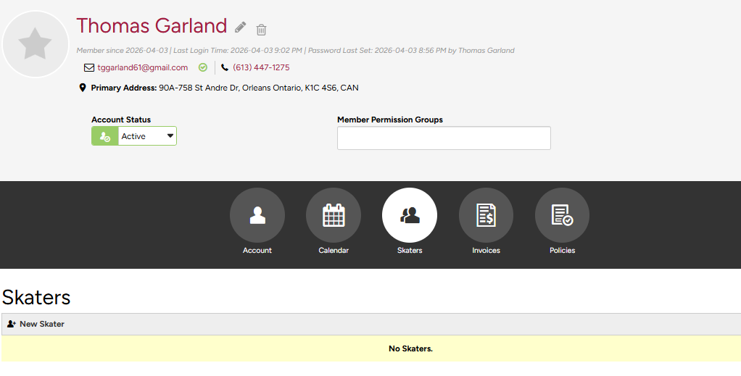

Fill out all required information for your skater and then click Add Skater.
